Name of Student : Raghav Mahesh Sarda PRN: 25070122235
Subject: Programming with Java Semester: III
ASSIGNMENT No : 18 Year: AY 2026-27
TITLE : Java GUI Button Event Handling

Problem Statement
Write a Java GUI program to demonstrate button click event handling.

Learning Objectives
To implement button click events using Java event handling mechanisms.

Program:
GUICalc.java
// Assignment 18 - Exercise 1: GUI Calculator using Java Swing
import javax.swing.*;
import java.awt.*;
import java.awt.event.*;
public class GUICalc implements ActionListener
{
JFrame frame; // Top-level window frame
JTextField num1txt, num2txt; // Input text fields
JLabel resultlabel; // Label to display result
JButton addbutton, subbutton; // Operation buttons

GUICalc() // Constructor to build calculator GUI
{
frame = new JFrame("Simple Calculator"); // Creating window frame
frame.setSize(350, 220); // Setting frame dimensions
frame.setLayout(new GridLayout(4, 2, 10, 10)); // Setting grid layout with spacing
frame.setDefaultCloseOperation(JFrame.EXIT_ON_CLOSE); // Closing behavior

JLabel lbl1 = new JLabel("First Number: "); // Label
num1txt = new JTextField(); // Text field

JLabel lbl2 = new JLabel("Second Number: "); //
num2txt = new JTextField();

addbutton = new JButton("Add (+)"); // Addition button
subbutton = new JButton("Subtract (-)"); // Subtraction button

resultlabel = new JLabel("Result: "); // Label for showing output
resultlabel.setFont(new Font("Arial", Font.BOLD, 14));

addbutton.addActionListener(this); // Registering addition button listener
subbutton.addActionListener(this); // Registering subtraction button listener

frame.add(lbl1); // Adding label
frame.add(num1txt); // Adding textfield
frame.add(lbl2);
frame.add(num2txt);
frame.add(addbutton);
frame.add(subbutton);
frame.add(resultlabel);

frame.setVisible(true); // Making window visible
}

public void actionPerformed(ActionEvent e) // Event handler method
{
try // Handling parsing errors
{
double n1 = Double.parseDouble(num1txt.getText());
double n2 = Double.parseDouble(num2txt.getText());
double res = 0; // Variable to store answer

if(e.getSource() == addbutton) // Addition condition
{
res = n1 + n2;
resultlabel.setText("Result: " + res);
}
else if(e.getSource() == subbutton) // Subtraction condition
{
res = n1 - n2;
resultlabel.setText("Result: " + res);
}
}
catch(NumberFormatException ex) // Catching invalid inputs
{
resultlabel.setText("Error: Enter valid numbers!");
}
}

public static void main(String args[]) // Main Method
{
new GUICalc();
}
}

BankBalanceGUICalc.java
// Assignment 18 - Exercise 2: Bank Balance Calculator GUI Application
import javax.swing.*;
import java.awt.*;
import java.awt.event.*;

public class BankBalanceGUICalc implements ActionListener
{
JFrame frame; // Top-level window frame
JTextField initbaltxt, transacamttxt; // Input text fields
JLabel updatedballabel; // Label to display updated balance
JButton depositbutton, withdrawbutton; // Action buttons
double currentBal = 0.0; // Variable to track balance
boolean initflag = false; // Flag to check initial balance set

BankBalanceGUICalc() // Constructor to build GUI
{
frame = new JFrame("Bank Balance Calculator"); // Creating window frame
frame.setSize(420, 260); // Setting frame dimensions
frame.setLayout(new GridLayout(5, 2, 10, 10)); // Setting grid layout with padding
frame.setDefaultCloseOperation(JFrame.EXIT_ON_CLOSE); // Closing behavior

JLabel initlabel = new JLabel("Initial Balance: "); // Label for initial balance
initbaltxt = new JTextField(); // Text field for initial balance

JLabel transacamtlabel = new JLabel("Transaction Amount: "); // Label for transaction amount
transacamttxt = new JTextField(); // Text field for transaction input

depositbutton = new JButton("Deposit (+)");
withdrawbutton = new JButton("Withdraw (-)");

updatedballabel = new JLabel("Updated Balance: $0.00"); // Output label
updatedballabel.setFont(new Font("Arial", Font.BOLD, 13));

depositbutton.addActionListener(this); // Registering deposit listener
withdrawbutton.addActionListener(this); // Registering withdraw listener

frame.add(initlabel);
frame.add(initbaltxt);
frame.add(transacamtlabel);
frame.add(transacamttxt);
frame.add(depositbutton);
frame.add(withdrawbutton);
frame.add(updatedballabel);

frame.setVisible(true);
}

public void actionPerformed(ActionEvent e) // Event handler method
{
try
{
if(!initflag) // Initializing starting balance on first action
{
currentBal = Double.parseDouble(initbaltxt.getText());
initflag = true; // Setting initialized flag to true
initbaltxt.setEditable(false);
}

double amt = Double.parseDouble(transacamttxt.getText());

if(amt <= 0) // Validating positive transaction amount
{
JOptionPane.showMessageDialog(frame, "Please enter an amount greater than 0.");
return;
}

if(e.getSource() == depositbutton) // Deposit condition
{
currentBal += amt; // Adding amount to balance
updatedballabel.setText("Updated Balance: $" + currentBal);
transacamttxt.setText(""); // Clearing transaction field
}
else if(e.getSource() == withdrawbutton) // Withdraw condition
{
if(amt > currentBal) // Insufficient funds condition
{
JOptionPane.showMessageDialog(frame, "Insufficient Balance for this withdrawal!");
}
else // Valid withdrawal
{
currentBal -= amt; // Subtracting amount from balance
updatedballabel.setText("Updated Balance: $" + currentBal);
transacamttxt.setText(""); // Clearing transaction field
}
}
}
catch(NumberFormatException ex) // Catching invalid inputs
{
JOptionPane.showMessageDialog(frame, "Invalid numeric input entered!");
}
}

public static void main(String args[]) // Main Method
{
new BankBalanceGUICalc();
}
}

Output:
GUICalc.java
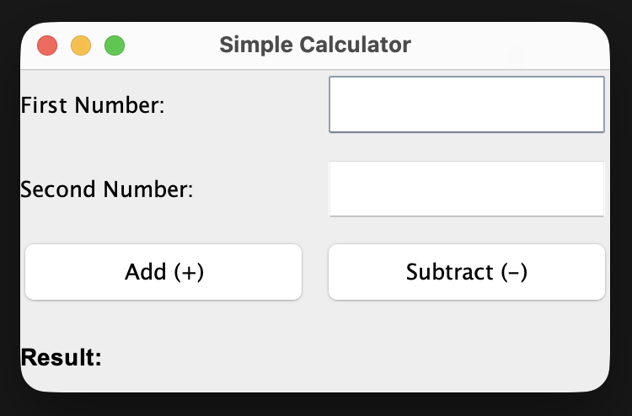
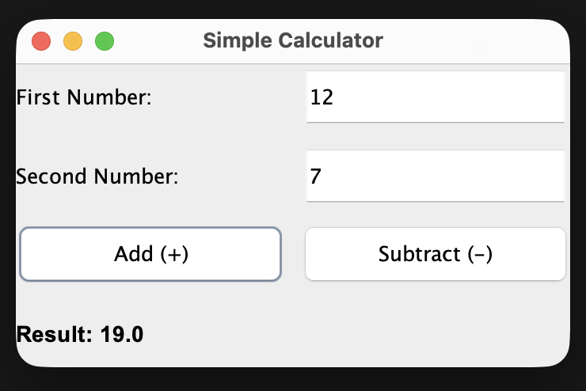
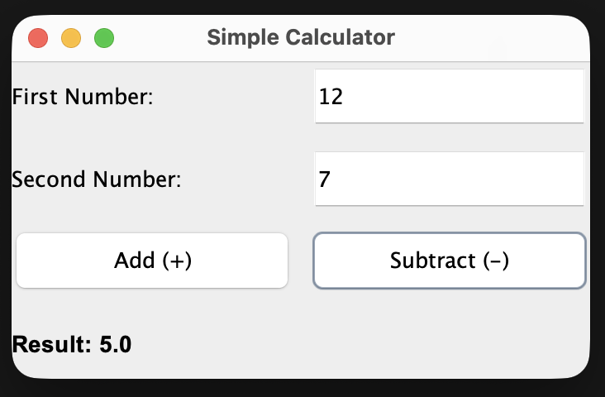

BankBalanceGUICalc.java
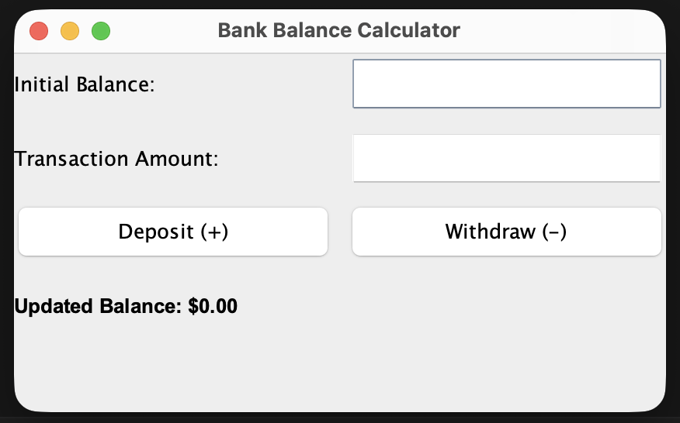
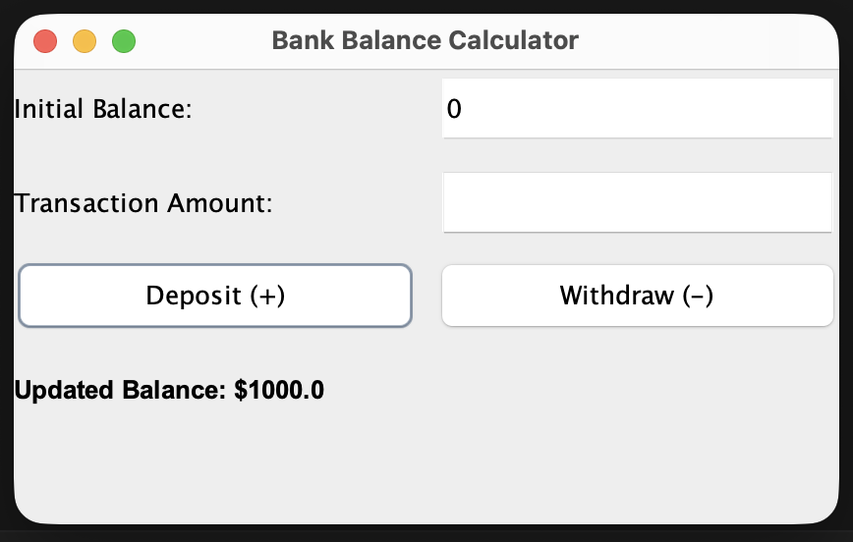
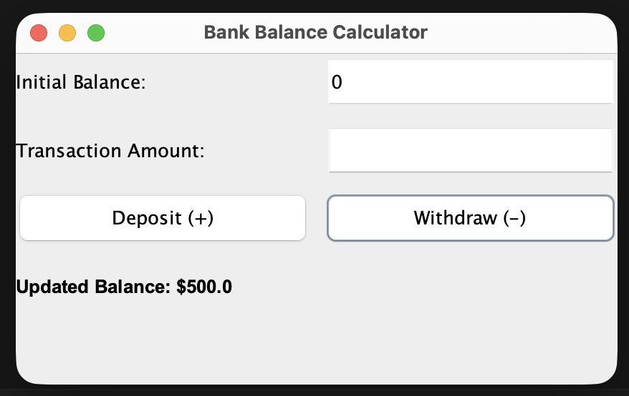

Conclusion:
In this assignment, the concepts of graphical user interface design and button click event handling using the Java Swing framework and the ActionListener interface were successfully implemented and verified. The GUI Calculator demonstrated basic arithmetic operations, while the Bank Balance Calculator effectively managed dynamic financial state changes through interactive deposit and withdrawal triggers, preventing invalid transactions and maintaining updated record displays.

